 | YEAR 12 MATHEMATICS SPECIALIST  SEMESTER ONE 2016  TEST 1: Complex Numbers

Name: _______________________
Thursday 3rd March
Time: 55 minutes Mark /45 = %

- Answer all questions neatly in the spaces provided. Show all working.
- You are permitted to use the Formula Sheet in both sections of the test.
- You are permitted one A4 page (one side) of notes in the calculator assumed section.

Calculator free section Suggested time: 30 minutes /25

- [7 marks]

A complex polynomial is defined by .
When is divided by , there is a remainder of .

  - Show that
[2]

  - Use synthetic substitution to evaluate
[2]

  - Determine all solutions to
[2]

  - Write as a product of linear factors
[1]

- [6 marks – 1 each]
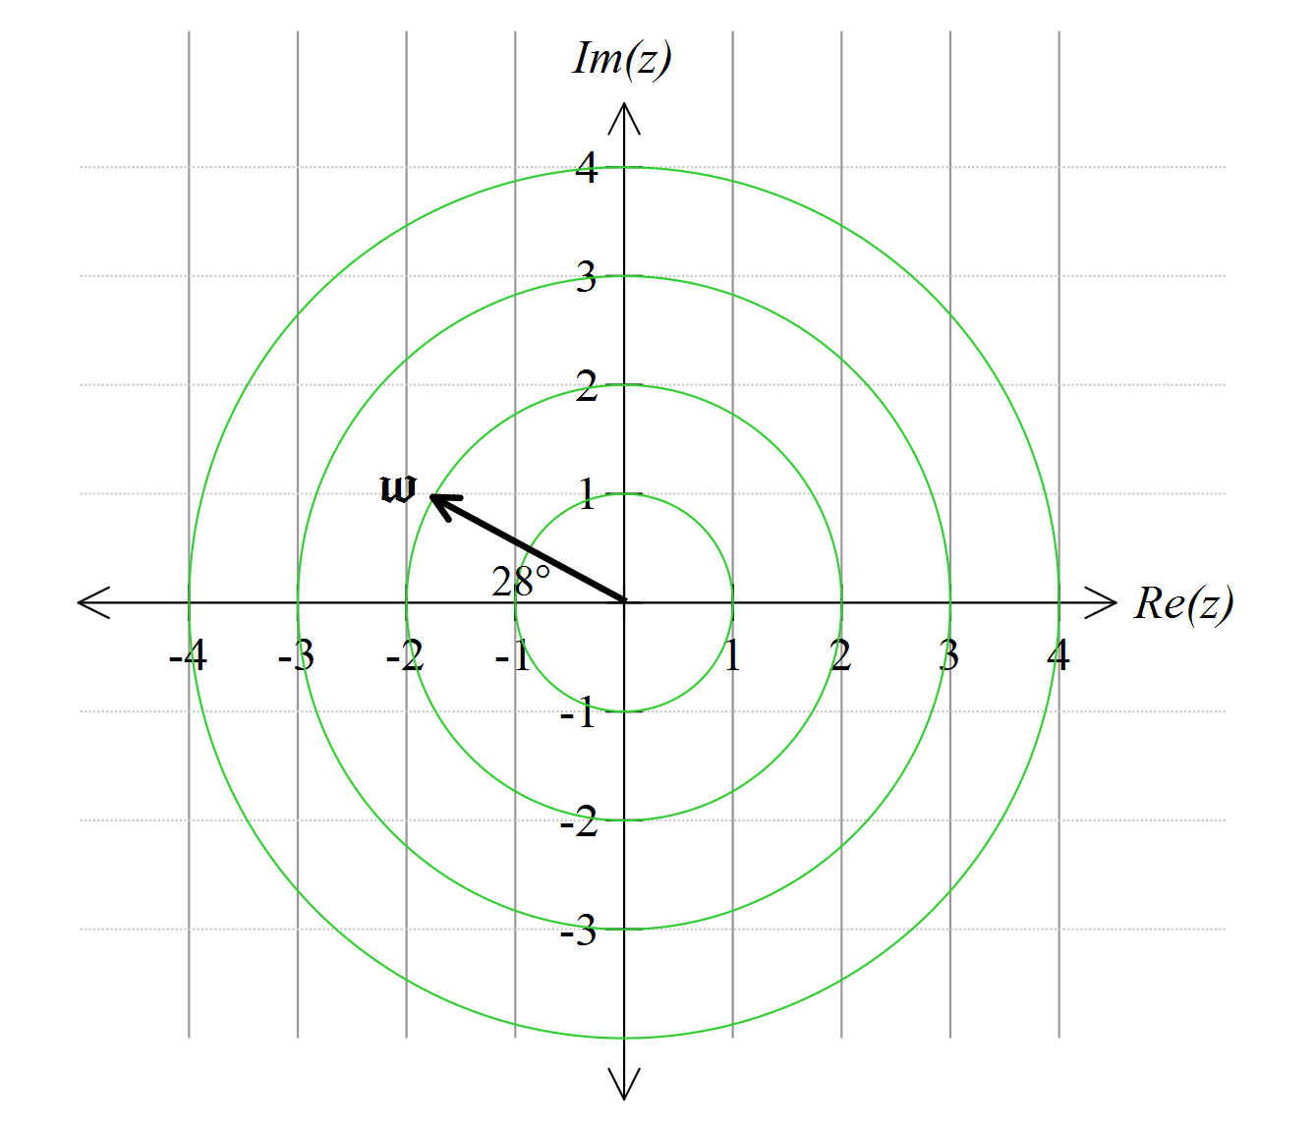
A complex number is defined by the vector shown.
Add these vectors to the diagram:

- 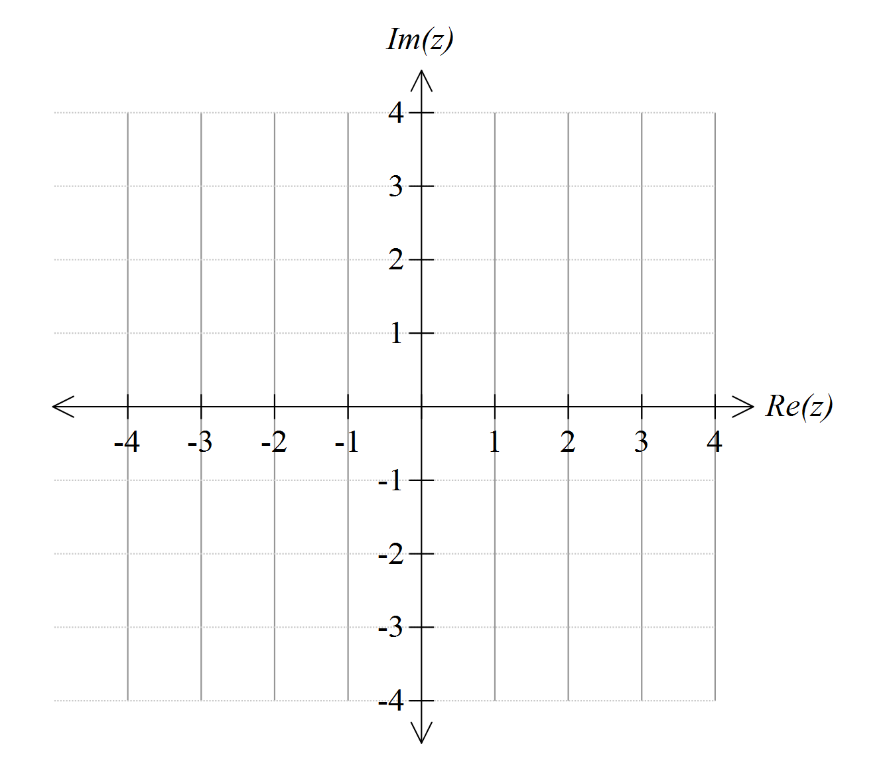[4 marks – 2 each]

  - Sketch the region which satisfies the inequality

  - This region can also be represented by an inequality of the form . What are the values of a and b?

- [4 marks]
Determine all solutions to .

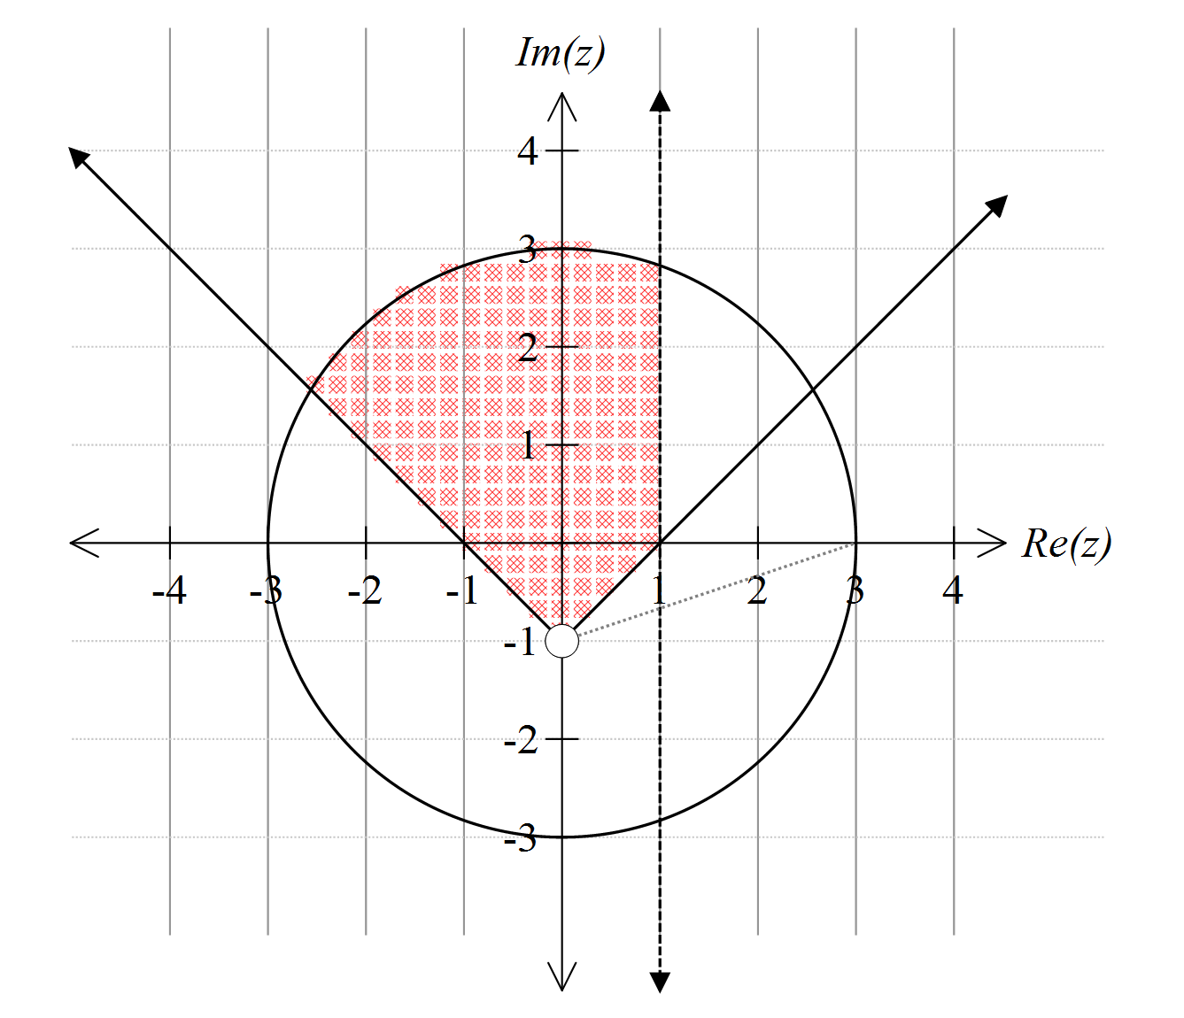
- [4 marks]

Write inequalities needed to define the shaded region:

Calculator assumed section Suggested time: 25 minutes /20
Name: _______________________
- [8 marks]
Complex numbers are defined by and .
  - Write in polar (cis) form
[1]

  - Convert to rectangular form

[1]
  - Calculate in polar form

[2]
  - Calculate in both polar and rectangular forms

[2]
  - Show clearly how to use your result in (d) to find an exact value for
[2]

- [5 marks]
Identify the centre and the radius of the circle in the complex plane with equation

- [7 marks]
Two complex numbers are defined by and .
On this Argand diagram, P represents z, Q is the product , R is and M the mid-point of QR
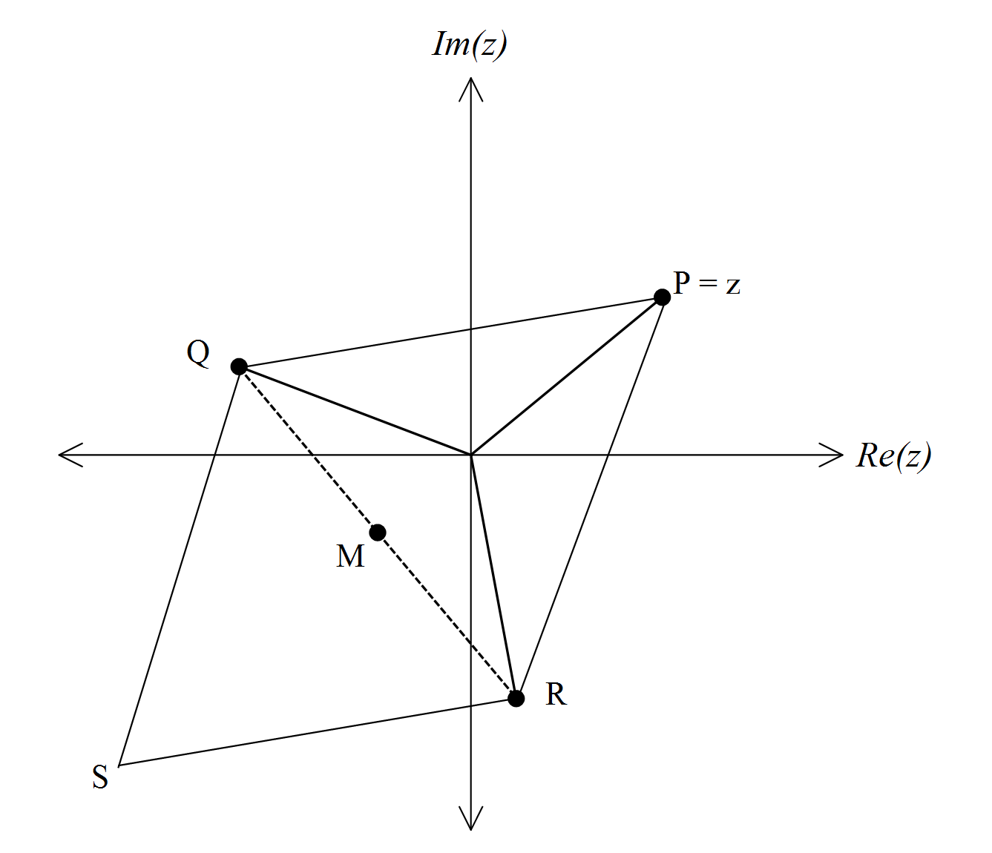
  - Write and in polar form
[2]

  - Evaluate and hence, or otherwise, show that M represents the complex number
[3]

  - S is chosen so that QPRS is a parallelogram. Which number is represented by S?
[2]

